**Binary Multiplication**

**Introduction**

In this assignment, I will be explaining how to do binary multiplication. Multiplying two binary codes are simple. They are two methods which I will be explain and one of them is easier to complete and the other is longer. As binary addition, you need to know the following rules in order to complete this task:

1. 0*0=0
2. 0*1=0
3. 1*0=0
4. 1*1=0

**Examples**

**11100 * 0011** is how it looks like. It is no longer but it could be if you want it to. Long multiplication is the method I will be explaining today. Every time you add the two together, using the rules, you have to place a 0 every time you move on to the other one; same as long division. So, as the picture shows, the second line adds one 0 because you move on to the other code. Line 3 adds two zeros. Once you have times it together, you do binary addition to add it together.

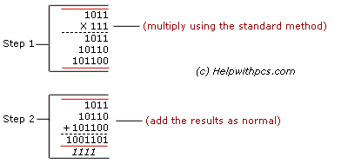

This is the addition part but to get it you need to times it together. Remember to use the carrying.

**RULES**

**0*0 = 0**

**0*1= 1**

**1*0= 1**

**1*1= 0 carry 1**

  11100

* 0011

11100

111000

0000000

00000000

01010100

111

**Example**

This one is easier. All you have to do is change it into binary. This explains how to do it. First of all you use the place values to convert it. As you can see below, once it is done, you times them together and you get your answer which is 60. Depending on how the teacher/examiner wants to see the answer, you use the place values to insert it within the values. The answer is 0 0 1 1 1 1 0 0. This method is used to check your answer. I used this method for the worksheets to check my answer.

**11100 = 16 + 8 + 4 = 20**

**\* 0011 = 2 + 1 = 3**

**20 * 3 = 60**

**128 64 32 16 8 4 2 1**

**0 0 1 1 1 1 0 0**